Betsy Schwarzentraub
generousstewards.com Facebook: Betsy Schwarzentraub, Betsy Schwarzentraub Author Vibrant Rhythms newsletter

 | February 2027
Mon | Tue | Wed | Thu | Fri | Sat | Sun
  1 Epiphany season continues | 2 | 3 | 4 | 5 | 6 |   7 Transfiguration Sunday
8 | 9 | 10 | 11 |   12 Ash Wednesday | 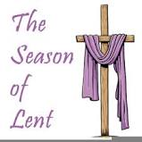  13 Lent season continues | 14
15 | 16 | 17 | 18 | 19 | 20 | 21
22 | 23 | 24 | 25 | 26 | 27 | 28

