Betsy Schwarzentraub
generousstewards.com Facebook: Betsy Schwarzentraub, Betsy Schwarzentraub Author Vibrant Rhythms
 | January 2027
Mon | Tue | Wed | Thu | Fri | Sat | Sun
 |  |  |  | 1 Christmas season continues | 2 | 3 Epiphany Sunday  
4 | 5 | 6 Epiphany  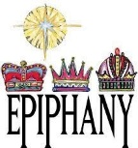 | 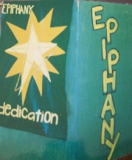  7 Epiphany season continues | 8 | 9 | 10 Baptism of the Lord  
11 | 12 | 13 | 14 | 15 | 16 | 17
18 | 19 | 20 | 21 | 22 | 23 | 24
25 | 26 | 27 | 28 | 29 | 30 | 31

