Betsy Schwarzentraub
generousstewards.com Facebook: Betsy Schwarzentraub, Betsy Schwarzentraub Author Vibrant Rhythms newsletter
 | December 2026
Sun | Mon | Tue | Wed | Thu | Fri | Sat
 |  | 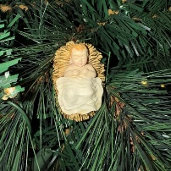  1 Advent continues | 2 | 3 | 4 | 5
6 Second Sun. of Advent | 7 | 8 | 9 | 10 | 11 | 12
13 Third Sun. of Advent | 14 | 15 | 16 | 17 | 18 | 19
  20 Fourth Sun. of Advent | 21 | 22 | 23 |   24 Christmas Eve |   25 Merry Christmas! | 26
27 First Sunday of Christmas | 28 | 29 | 30 |   31 Watchnight
More Calendars from WinCalendar: Jan 2027, Feb 2027, Mar 2027

